Guidelines for Providing New Information to Study Participants

The TCPS2, the ICH-GCP, and the US Code of Federal Regulations (CFR) require that research
participants be provided with any significant new findings developed during the course of the
research which may relate to the study participant’s willingness to continue participation. These “significant new findings” will be evaluated on a case-by-case basis by the REB. While the
Belmont Report does not specifically address re-consenting, it does provide an additional ethical requirement that research participants should be notified of significant new findings that might affect their long-term health even after they have completed participation in the research study.

Neither the TCPS2, nor the regulatory documents provide guidance on the manner or extent of
documentation required to satisfy these regulatory or ethical responsibilities. Significant new findings often result in changes to the consent form or protocol after participants have signed a consent document. The purpose of this document is to provide guidance regarding the types of information the REB considers to constitute significant new findings, what changes to the protocol or consent form should and should not be conveyed to participants, and the means
through which the REB expects significant new findings or changes to be conveyed to
current/past participants and to future participants.

What constitutes significant new findings requiring reporting to current/past participants?

Significant new findings generally include, but are not limited to:

Changes in potential or actual risks or benefits to participants.
Examples:
- Changes in standard of care, such that participation in research can increase risk
to participants (i.e., participants would be deprived of the standard of care by
continuing to take part in the research study);
- Identification of new risks to participants currently receiving the study treatment;
- Identification of potential late-term effects for participants who completed study
treatment;
- Discovery that a life threatening of severely debilitating side effect occurs more
frequently than previously expected.

Addition or deletion of study procedures or change in number of visits required.
Examples:
- Addition of monitoring procedures;
- Addition of new instruments or questionnaires to the study;
- Collection of new or different information from subjects.

Substantive alterations to the treatment participants expect to or currently receive.
Examples:
- The frequency of dosing is increased or decreased;
- The route of study drug administration is altered.

Substantive changes in potential costs or payments to subjects.
Examples:
- A drug previously paid for/provided by the study will no longer be provided;
- Reimbursement for costs of study participation are increased or decreased.

How to report significant new information

Significant new information or changes to the protocol should be conveyed to current/past
participants (when applicable) via a consent update form. Use of a consent update form, rather
than revising the consent document is mandatory for participants already enrolled in a research
study (current and past).

The consent update form must be implemented (i.e., method of providing the document to
participants) according to the relevance and urgency of the new information.
For example:

Recall participant (i.e., schedule for an ad hoc visit asap): recall the participant
immediately if new information reflects changes in potential or actual risks or benefits
that are significant;

A telephone call to participants: inform the participant via telephone - this can be
documented in the research file regarding when and who provided the new information to
participants. This method is encouraged when verification that participants have received
this information is needed (e.g., due to potential increased risks) and participants are no
longer being seen in person or a significant gap in time would occur between when the
new findings are discovered and the next scheduled contact with the participant;

A letter to participants: this mode of communication may be suitable for information that
needs to be communicated to participants when participants are no longer seen by the
researcher in person, and for information which is not life threatening or time sensitive.
The OCREB amendment cover form provides options/choices for the appropriate
implementation of the consent update form, determined by the significance/urgency of the
information - options are selected by the Provincial Applicant, and then reviewed by the board.

REB review of significant new information
Significant new information that the researcher proposes to disseminate should be submitted for review (by the provincial applicant) using an amendment application.

In general, the REB must review the new information to be provided to participants prior to its
dissemination, unless the information must be provided to participants urgently to eliminate an
apparent immediate hazard to participants or others. (i.e., urgent new safety information) In the case where this information must be provided to participants prior to REB approval the
researcher must report the dissemination of this information to REB as soon as possible.

In the case where the new findings are urgent and must be reported to participants orally before REB approval of the amendment can be obtained, the /Provincial Applicant (or participating centre applicant) should contact the responsible REC from the study workspace) or from the amendment or reportable event workspace if applicable). This request should include the following information:

1. Confirmation that the new information is a safety risk, and the rationale for its
immediate implementation;

2. Confirmation that the sponsor is recommending urgent provision of this information
to study participants;

3. Confirmation that the PI has reviewed the information and is recommending urgent
provision of this information to study participants; and

4. The recommended process for disseminating the information (e.g., by phone).

5. The content of the information (script or text) that will be provided orally to the study
participants.

Once reviewed and approved, OCREB will disseminate the approved oral script to all
participating centres.

In the subsequent amendment related to the new information, in Section 1.2, Question 3 of the
amendment cover form, the Provincial Applicant should note that the new information required urgent oral dissemination to the study participants and should include the OCREB approval oral text.

When the Consent Update Form is not Required
The REB is aware that study sponsors often request or require researchers to present revised
consent documents to participants to sign ("re-consent") when they have been revised, regardless of the significance of the new information or change. In many cases informing participants is inappropriate and may result in needless burden on the participants, presentation of irrelevant information to the participants and potential dilution of the impact of significant new findings. Consequently, the REB does not require the use of a Consent Update Form when the revisions to consent documents would not or could not affect the participants’ willingness to continue participation in the research study.

Examples of situations the REBs generally would not require a consent update form include:

- The version number or date on the consent form has been revised and no other changes
- have been made;

- A minor increase in number of participants to be enrolled in the study;

- New risk information about the study drug is discovered which is not related to late
- effects and all participants have completed study treatment;

- Addition of new study procedures or additions of study visits that do not pertain to
- participants already enrolled in the study (e.g., changes made to screening procedures that
- only affect new participants).

Guidelines on the appropriate method for providing the new information
The following guidelines indicate the appropriate methods to use when providing significant new findings to research participants, and the required documentation for notification. The format for disclosure will be dependent on the applicant’s selection, followed by the REB’s review of the new information, the new risks identified and the overall risk of the research. REB approval will include specific information related to notification processes for the consent update form based on their review of the new information.

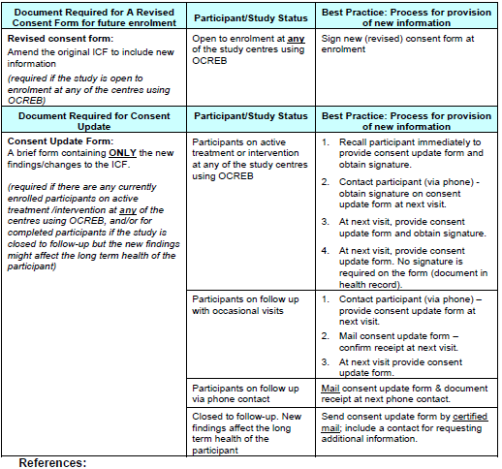

References:
1. TCPS2: Chapter 3:3., Chapter 11: 11.8;
2. 45 CRF 46.103(b) (4) (iii) and 46.117;
3. 45 CRF 46.116(a) and (b);
4. 45 CFR 46.111(a) (1) and (2);
5. ICH GCP 4.8.2;
6. 21 CFR 50.25 (b) (5);
7. Re-Consenting Subjects Guidance, University of Wisconsin.
http://kb.wisc.edu/page.php?id=18663

